Wednesday Night Fellowship Meeting – 06/02/2021
Today’s Message: The Mountains of Israel Part 2, Israel and The Land

Text: Hebrews 10:19, Ezekiel 36:1-5, Deuteronomy 4:24, Isaiah 35:1, Zechariah 14:2,
Zechariah 13:8, Zechariah 14:3, Zechariah 12:10, Zechariah 13:1, Revelation 19:11-18,
Isaiah 63, Matthew 24:8, 2 Thessalonian 2:7-8, Joel 2:28, Joel 2:31, 1 Thessalonians 5:9, Matthew 24:32-35, John 5:43, Matthew 12:31-32

Email:
mcfilesfaith@gmail.com – Faith related questions
mcfilesprayers@gmail.com – Prayer Requests

Notes: www.spiritjournals.orgn -or- https://chrismc77.wixsite.com/spiritjournals/

Bible Translation: King James Version

Hebrews 10:19:
Having therefore, brethren, boldness to enter into the holiest by the blood of Jesus,

Ezekiel 36:1-5:
- Ezekiel 35 God Prophesied AGAINST Mount Seir (Edom)
- His Rebuke was for Their Hatred and Demonic Schemes against Israel
- This Perpetual Hatred is Same Now as it was Then (Ongoing and Ancient)
- Ezekiel 36 We See Two Things Emerging
  - 1-15 The Lord is Still Addressing Edom AND The Mountains of Israel
  - 36:16-37:14 – Israel’s Restoration

Ezekiel 33-48 ALL CHAPTER’S DEAL WITH ISRAEL’S HISTORY
Ezekiel 33 – Warning to Israel’s Watchmen (Last Days)
Ezekiel 34 – Warning to Israel’s Shepherds
Ezekiel 35 – Rebuke of Edom (Current Day)
Ezekiel 36 – Promise to Mountains of Israel (Kingdom)
Ezekiel 37 – Vision of the Dry Bones – Israel’s Revival and Travail during Tribulation
Ezekiel 38-39 – Armageddon
Ezekiel 40-48 – Christ’s Return and The Kingdom Age

Ezekiel 36:1-3:
¹Also, thou son of man, prophesy unto the mountains of Israel, and say, Ye mountains of Israel, hear the word of the LORD: ²Thus saith the Lord GOD; Because the enemy hath said against you, Aha, even the ancient high places are ours in possession: ³Therefore prophesy and say, Thus saith the Lord GOD; Because they have made you desolate, and swallowed you up on every side, that ye might be a possession unto the residue of the heathen, and ye are taken up in the lips of talkers, and are an infamy of the people:

Ezekiel 36:4:
Therefore, ye mountains of Israel, hear the word of the Lord GOD; Thus saith the Lord GOD to the mountains, and to the hills, to the rivers, and to the valleys, to the desolate wastes, and to the cities that are forsaken, which became a prey and derision to the residue of the heathen that are round about;

Ezekiel 36:5:
Therefore thus saith the Lord GOD; Surely in the fire of my jealousy have I spoken against the residue of the heathen, and against all Idumea, which have appointed my land into their possession with the joy of all their heart, with despiteful minds, to cast it out for a prey.

Deuteronomy 4:24:
For the LORD thy God is a consuming fire, even a jealous God.

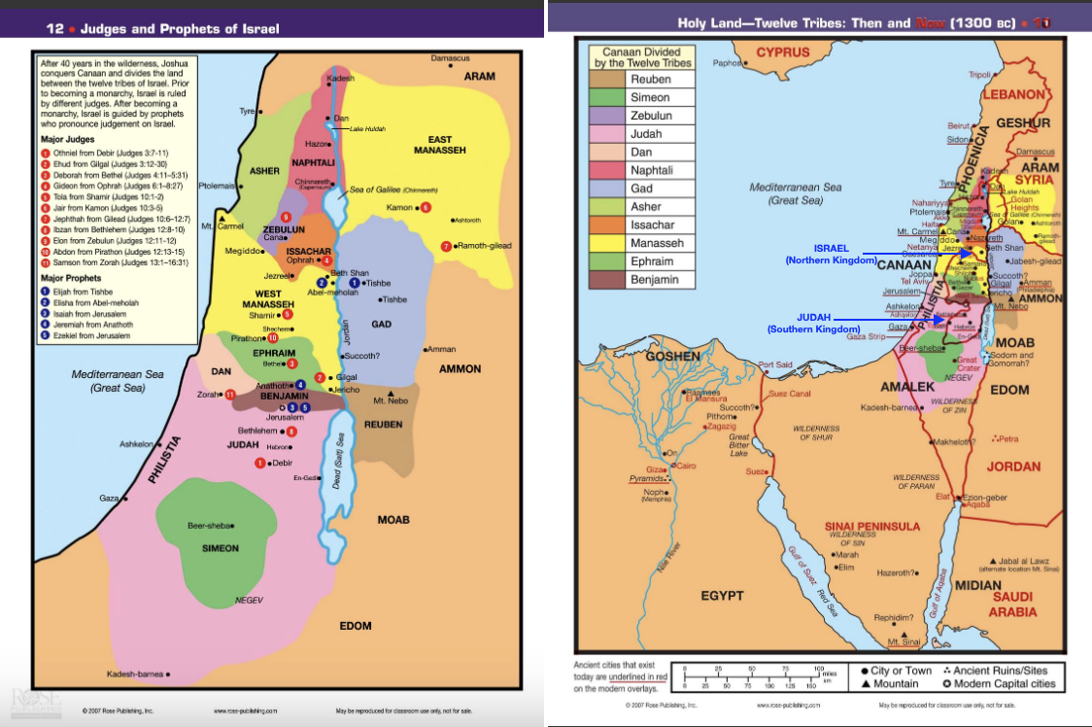

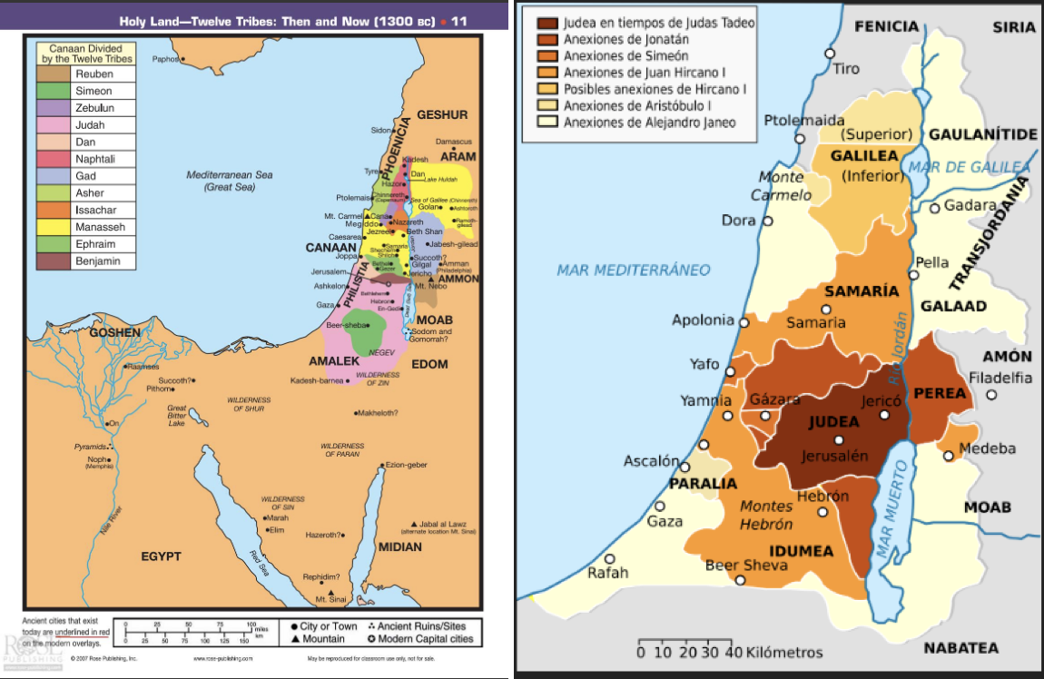

Ezekiel 36:1-5:
- Ezekiel 35 God Prophesied AGAINST Mount Seir (Edom)
- His Rebuke was for Their Hatred and Demonic Schemes against Israel
- This Perpetual Hatred is Same Now as it was Then (Ongoing and Ancient)
- Ezekiel 36 We See Two Things Emerging
  - 1-15 The Lord is Still Addressing Edom AND The Mountains of Israel
  - 36:16-37:14 – Israel’s Restoration

Isaiah 35:1:
The wilderness and the solitary place shall be glad for them; and the desert shall rejoice, and blossom as the rose.

Five Points:
All nations will turn against Israel in last days (Zechariah 14:2)
2/3 of the Jewish people will perish (Zechariah 13:8)
Messiah will fight for Israel when no hope is left (Zechariah 14:3)
The nation will repent (Zechariah 12:10)
The nation will be cleansed of sin (Zechariah 13:1)

From the Five Points:

Zechariah 14:2:
For I will gather all nations against Jerusalem to battle; and the city shall be taken, and the houses rifled, and the women ravished; and half of the city shall go forth into captivity, and the residue of the people shall not be cut off from the city.

Zechariah 13:8:
And it shall come to pass, that in all the land, saith the LORD, two parts therein shall be cut off and die; but the third shall be left therein.

Zechariah 14:3:
Then shall the LORD go forth, and fight against those nations, as when he fought in the day of battle.

Zechariah 12:10:
And I will pour upon the house of David, and upon the inhabitants of Jerusalem, the spirit of grace and of supplications: and they shall look upon me whom they have pierced, and they shall mourn for him, as one mourneth for his only son, and shall be in bitterness for him, as one that is in bitterness for his firstborn.

Zechariah 13:1:
In that day there shall be a fountain opened to the house of David and to the inhabitants of Jerusalem for sin and for uncleanness.

Ezekiel 36:5:
Therefore thus saith the Lord GOD; Surely in the fire of my jealousy have I spoken against the residue of the heathen, and against all Idumea, which have appointed my land into their possession with the joy of all their heart, with despiteful minds, to cast it out for a prey.

Revelation 19:11-18:
The Rider on the White Horse
¹¹And I saw heaven opened, and behold a white horse; and he that sat upon him was called Faithful and True, and in righteousness he doth judge and make war. ¹²His eyes were as a flame of fire, and on his head were many crowns; and he had a name written, that no man knew, but he himself. ¹³And he was clothed with a vesture dipped in blood: and his name is called The Word of God. ¹⁴And the armies which were in heaven followed him upon white horses, clothed in fine linen, white and clean. ¹⁵And out of his mouth goeth a sharp sword, that with it he should smite the nations: and he shall rule them with a rod of iron: and he treadeth the winepress of the fierceness and wrath of Almighty God. ¹⁶And he hath on his vesture and on his thigh a name written, KING OF KINGS, AND LORD OF LORDS.

Defeat of the Beast and False Prophet
¹⁷And I saw an angel standing in the sun; and he cried with a loud voice, saying to all the fowls that fly in the midst of heaven, Come and gather yourselves together unto the supper of the great God; ¹⁸That ye may eat the flesh of kings, and the flesh of captains, and the flesh of mighty men, and the flesh of horses, and of them that sit on them, and the flesh of all men, both free and bond, both small and great.

Isaiah 63:
God's Judgment on the Nations
1Who is this that cometh from Edom, with dyed garments from Bozrah? this that is glorious in his apparel, travelling in the greatness of his strength? I that speak in righteousness, mighty to save. ²Wherefore art thou red in thine apparel, and thy garments like him that treadeth in the winefat? ³I have trodden the winepress alone; and of the people there was none with me: for I will tread them in mine anger, and trample them in my fury; and their blood shall be sprinkled upon my garments, and I will stain all my raiment. ⁴For the day of vengeance is in mine heart, and the year of my redeemed is come. ⁵And I looked, and there was none to help; and I wondered that there was none to uphold: therefore mine own arm brought salvation unto me; and my fury, it upheld me. ⁶And I will tread down the people in mine anger, and make them drunk in my fury, and I will bring down their strength to the earth.

God's Mercies Recalled
⁷I will mention the lovingkindnesses of the LORD, and the praises of the LORD, according to all that the LORD hath bestowed on us, and the great goodness toward the house of Israel, which he hath bestowed on them according to his mercies, and according to the multitude of his lovingkindnesses. ⁸For he said, Surely they are my people, children that will not lie: so he was their Saviour. ⁹In all their affliction he was afflicted, and the angel of his presence saved them: in his love and in his pity he redeemed them; and he bare them, and carried them all the days of old. ¹⁰But they rebelled, and vexed his holy Spirit: therefore he was turned to be their enemy, and he fought against them.
¹¹Then he remembered the days of old, Moses, and his people, saying, Where is he that brought them up out of the sea with the shepherd of his flock? where is he that put his holy Spirit within him? ¹²That led them by the right hand of Moses with his glorious arm, dividing the water before them, to make himself an everlasting name? ¹³That led them through the deep, as an horse in the wilderness, that they should not stumble? ¹⁴As a beast goeth down into the valley, the Spirit of the LORD caused him to rest: so didst thou lead thy people, to make thyself a glorious name.

Prayer for Mercy
¹⁵Look down from heaven, and behold from the habitation of thy holiness and of thy glory: where is thy zeal and thy strength, the sounding of thy bowels and of thy mercies toward me? are they restrained? ¹⁶Doubtless thou art our father, though Abraham be ignorant of us, and Israel acknowledge us not: thou, O LORD, art our father, our redeemer; thy name is from everlasting. ¹⁷O LORD, why hast thou made us to err from thy ways, and hardened our heart from thy fear? Return for thy servants' sake, the tribes of thine inheritance. ¹⁸The people of thy holiness have possessed it but a little while: our adversaries have trodden down thy sanctuary. ¹⁹We are thine: thou never barest rule over them; they were not called by thy name.

ACTION: Read the following to prepare for next week’s teaching:

Ezekiel 33-48 ALL CHAPTER’S DEAL WITH ISRAEL’S HISTORY
Ezekiel 33 – Warning to Israel’s Watchmen (Last Days)
Ezekiel 34 – Warning to Israel’s Shepherds
Ezekiel 35 – Rebuke of Edom (Current Day)
Ezekiel 36 – Promise to Mountains of Israel (Kingdom)
Ezekiel 37 – Vision of the Dry Bones – Israel’s Revival and Travail during Tribulation
Ezekiel 38-39 – Armageddon
Ezekiel 40-48 – Christ’s Return and The Kingdom Age

Chris takes questions on End Time Bible Prophecy:

Assyrian Empire (746 - 609 BCE)

Matthew 24:8:
All these are the beginning of sorrows.

2 Thessalonian 2:7-8:
⁷For the mystery of iniquity doth already work: only he who now letteth will let, until he be taken out of the way. ⁸And then shall that Wicked be revealed, whom the Lord shall consume with the spirit of his mouth, and shall destroy with the brightness of his coming:

Joel 2:28:
And it shall come to pass afterward, that I will pour out my spirit upon all flesh; and your sons and your daughters shall prophesy, your old men shall dream dreams, your young men shall see visions:

Joel 2:31:
The sun shall be turned into darkness, and the moon into blood, before the great and the terrible day of the LORD come.

1 Thessalonians 5:9:
For God hath not appointed us to wrath, but to obtain salvation by our Lord Jesus Christ,

Matthew 24:32-35:
³²Now learn a parable of the fig tree; When his branch is yet tender, and putteth forth leaves, ye know that summer is nigh: ³³So likewise ye, when ye shall see all these things, know that it is near, even at the doors. ³⁴Verily I say unto you, This generation shall not pass, till all these things be fulfilled. ₃₅Heaven and earth shall pass away, but my words shall not pass away.

Read Book Daniel 7 – Goes into detail (character traits) about the “lawless” one/man of sin

John 5:43:
I am come in my Father's name, and ye receive me not: if another shall come in his own name, him ye will receive.

Matthew 12:31-32:
³¹Wherefore I say unto you, All manner of sin and blasphemy shall be forgiven unto men: but the blasphemy against the Holy Ghost shall not be forgiven unto men. ³²And whosoever speaketh a word against the Son of man, it shall be forgiven him: but whosoever speaketh against the Holy Ghost, it shall not be forgiven him, neither in this world, neither in the world to come.

Read Revelation Chapters 12, 13, 14 for more on the beast

